- USE CASE DIAGRAM
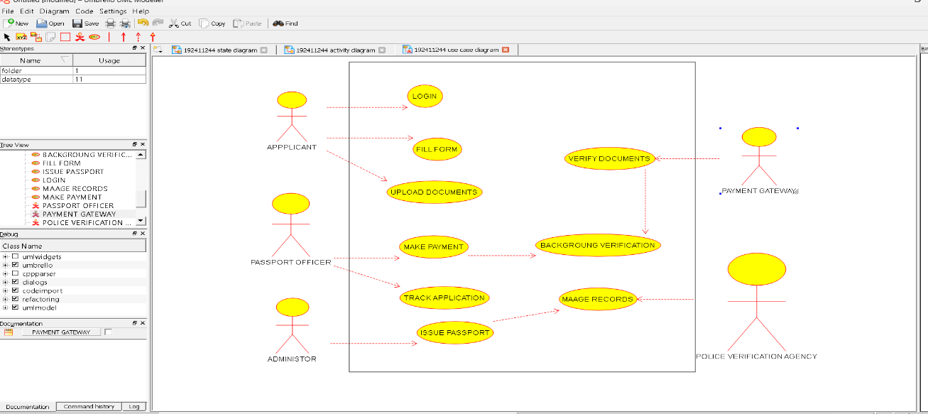

- DEPLOYMENT DIAGRAM
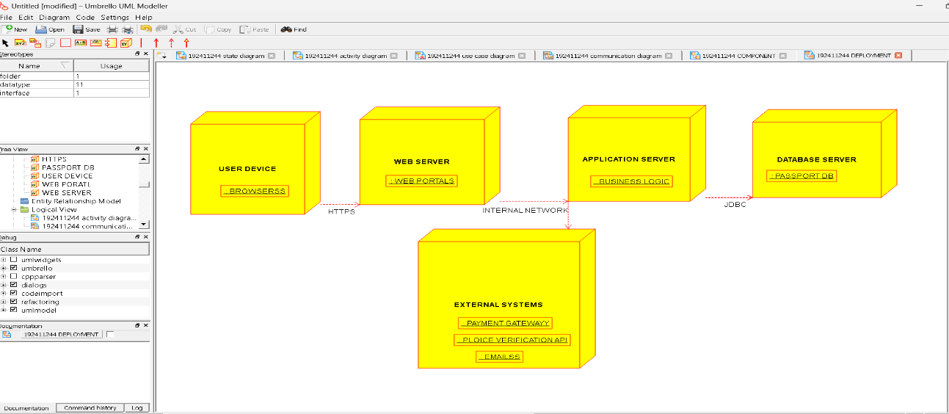

- COMPONENT DIAGRAM
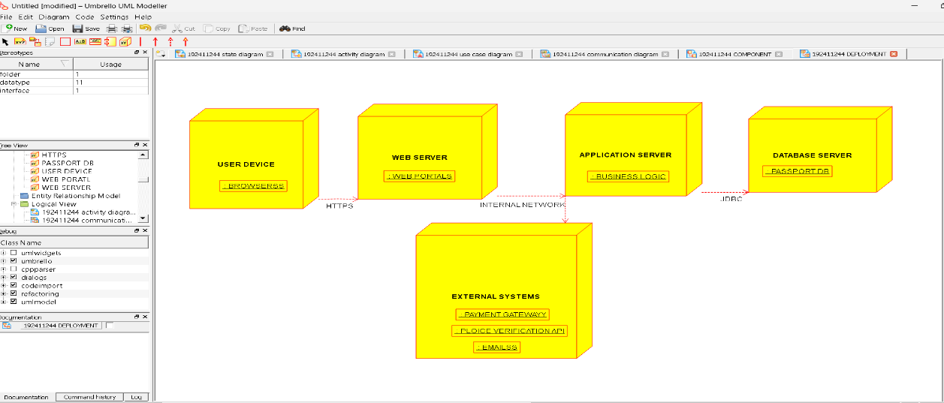

- COMMUNICATION DIAGRAM
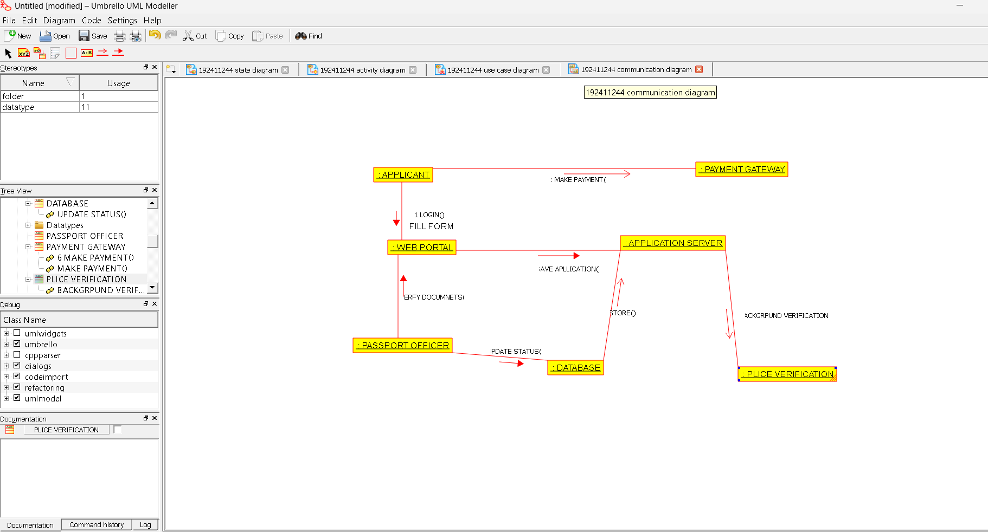

- ACTIVIVTY DIAGRAM
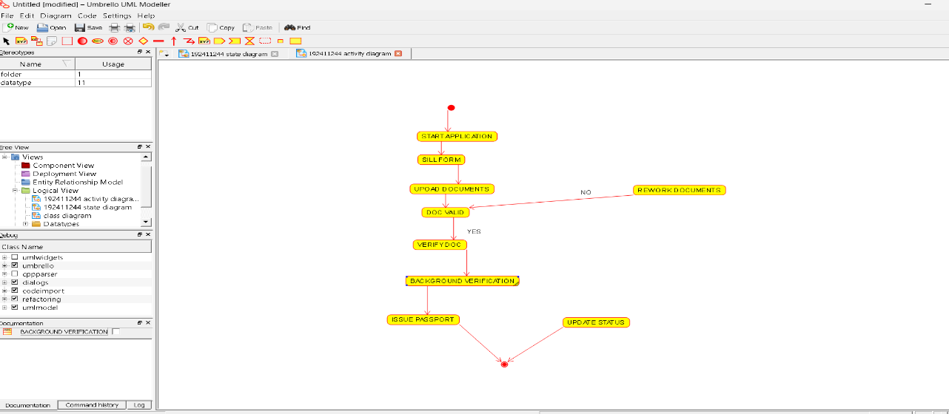

- STATE DIAGRAM
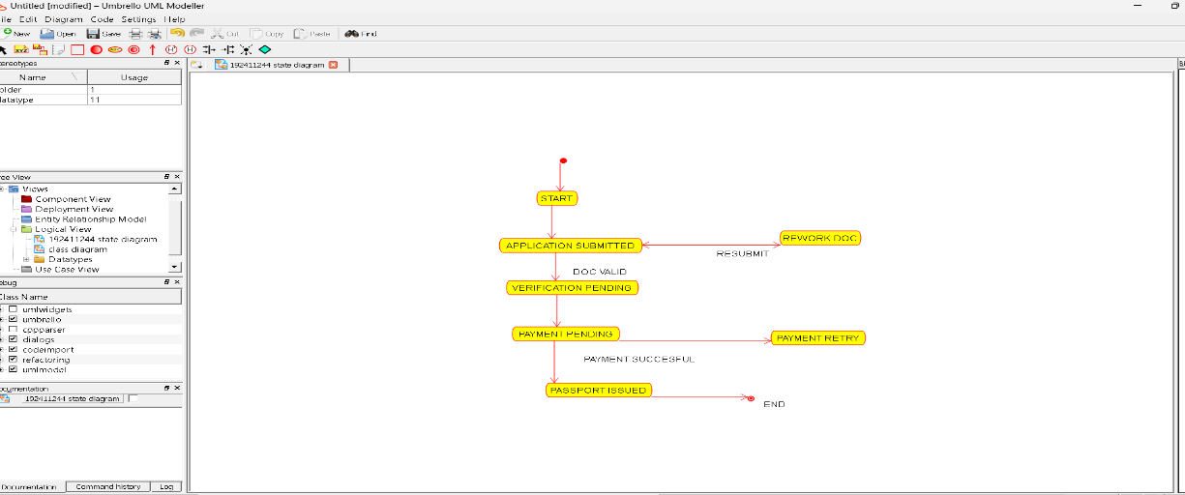

- SEQUENCE DIAGARAM
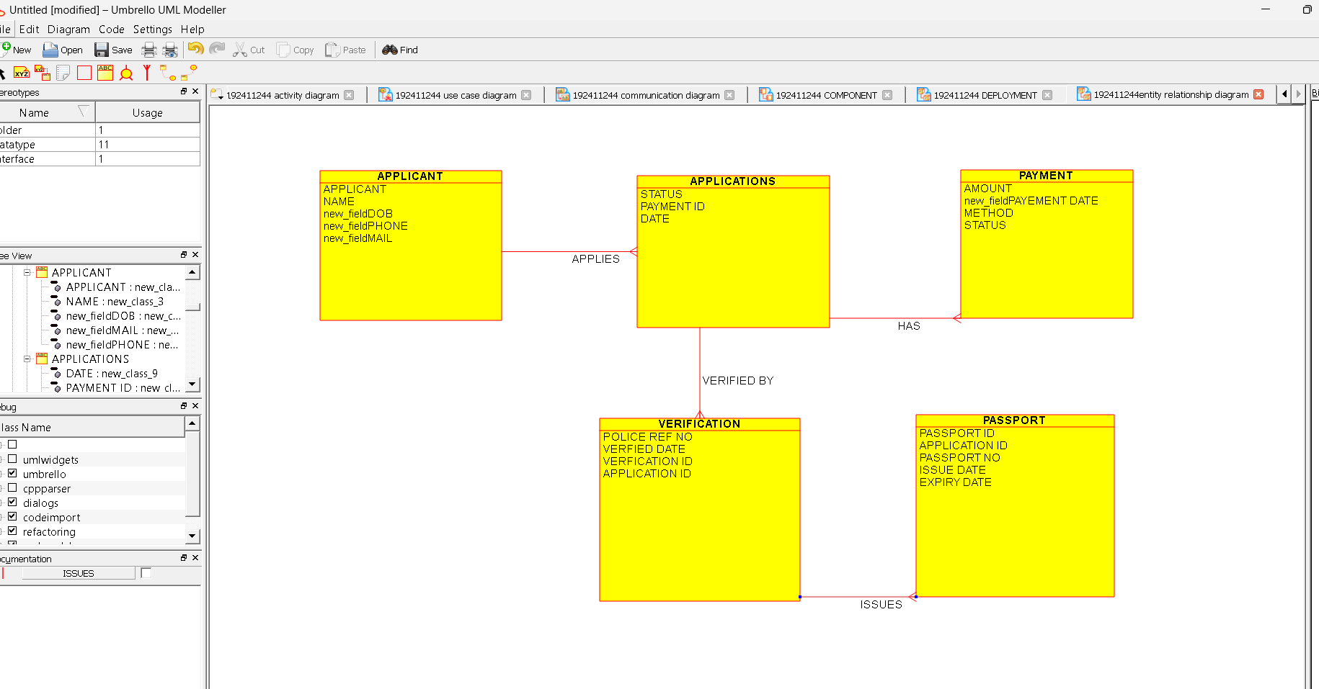
- PACKAGE DIAGARAM
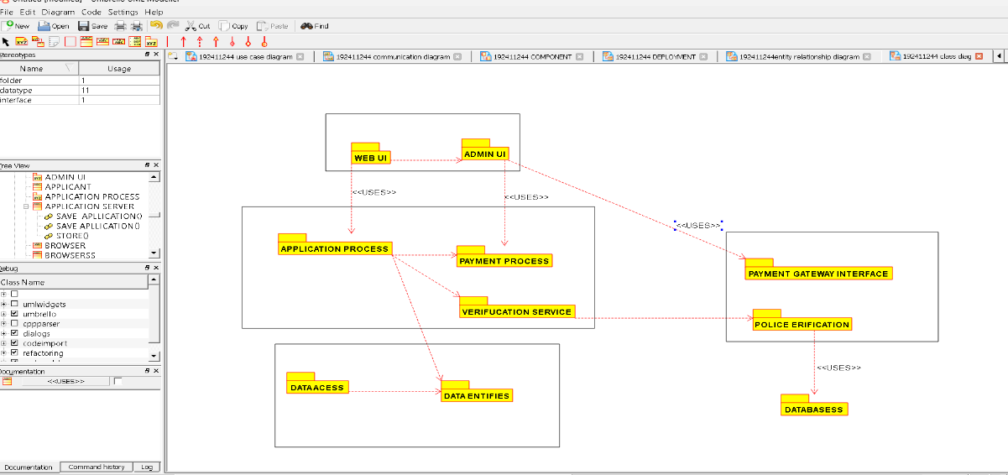

9.ENTITY REATIONSHIP DIAGRAM

